A
Synopsis Report On
“The Handwritten Digit Recognition System”

Submitted in Partial Fulfillment of the Requirements for the Award of the Degree of
Bachelor of Computer Science Engineering
in
Data Science & Artificial Intelligence
Submitted by
Ayush Yadav (202210101150081)

Under the Guidance of
Dr. Mohd. Nadeem
Assistant Professor
Department of Computer Science Engineering


Shri Ramswaroop Memorial University

Lucknow — Deva Road, Barabanki (UP)

ABSTRACT

The Handwritten Digit Recognition System is a deep learning-based application designed to automatically identify handwritten digits (0–9) from images. Manual recognition of handwritten data, such as forms, exam sheets, or bank cheques, is often time-consuming, labor-intensive, and prone to human error. Automating this process using artificial intelligence provides a faster, more accurate, and scalable solution.
This project utilizes Convolutional Neural Networks (CNNs) to extract features from digit images and classify them accurately. Prior to feeding images into the model, OpenCV is used for preprocessing, including resizing, normalization, and noise reduction, ensuring consistent input quality. The CNN model is trained on the widely-used MNIST dataset, allowing it to recognize a variety of handwriting styles and generalize effectively to unseen data.
To demonstrate the practical applicability of the system, a user-friendly interactive demo is implemented using Streamlit, where users can draw digits on a canvas and instantly view predictions. This interactive component enhances user engagement and provides a tangible visualization of the AI system’s performance.
The system is designed with scalability and flexibility in mind, allowing future expansion to recognize letters, symbols, or multi-digit numbers. Its applications span multiple domains, including education, banking, postal services, and digitization of historical records, contributing to efficiency and digital transformation.
Ultimately, the Handwritten Digit Recognition System combines advanced AI techniques, efficient image preprocessing, and an intuitive interface to provide an accurate, interactive, and practical solution for digit recognition tasks, making it an effective tool for both research and real-world applications.

INDEX

S.no. | Contents | Page No.
1 | Introduction | 1
2 | Problem Statement | 2
3 | Problem Objective and Scope | 3
4 | Methodology | 4
5 | Hardware & Software to be used | 5
6 | Project Contribution: Potential Impact and Significance | 6
7 | Module Requirement | 7
8 | Data Flow Diagram | 10
9 | ER Diagram | 11
10 | Use Cases | 12
11 | Conclusion | 13
12 | References | 14

FIGURES

S.no. | Figures | Page No.
1 | Figure 1: Level 0 DFD | 5
2 | Figure 2: Level 1 DFD | 5
3 | Figure 3: ER Diagram | 6

1. INTRODUCTION

In the modern digital era, the ability to automatically recognize handwritten content has become increasingly important in numerous applications, including banking, education, postal services, and document digitization. Handwritten digit recognition is a subset of this field, focusing on accurately identifying numeric characters (0–9) from images. Manual processing of handwritten digits is not only time-consuming and labor-intensive but also prone to errors due to variations in handwriting styles, image quality, and human oversight.
Recent advances in artificial intelligence (AI) and deep learning have enabled the development of systems capable of recognizing handwritten digits with high accuracy. Convolutional Neural Networks (CNNs), a type of deep learning architecture, are particularly effective in capturing spatial patterns and features in images, making them ideal for digit recognition tasks.
In this project, the Handwritten Digit Recognition System will use a combination of OpenCV for image preprocessing and CNNs for classification. The preprocessing step ensures that images are cleaned, resized, and normalized, which improves model performance and reduces errors caused by noise or inconsistencies in the input data. The CNN model will be trained on the MNIST dataset, which contains thousands of handwritten digit samples, allowing the system to generalize across different handwriting styles and achieve robust performance.
To make the system accessible and interactive, a user-friendly demo interface will be implemented using Streamlit, enabling users to draw digits on a canvas and receive real-time predictions. This approach not only demonstrates the practical capabilities of the model but also provides an educational tool for understanding how AI can be applied to computer vision problems.
The Handwritten Digit Recognition System is designed to be scalable, flexible, and applicable to real-world scenarios, providing a foundation for future expansion to recognize letters, symbols, or multi-digit numbers. By automating the recognition process, the system aims to save time, reduce errors, and enhance efficiency across various industries and educational settings.

2.PROBLEM STATEMENT

Handwritten digit recognition is a challenging problem due to the inherent variability in human handwriting, which can differ significantly in style, size, orientation, and thickness. Traditional manual recognition methods are time-consuming, error-prone, and inefficient, especially when processing large volumes of handwritten documents, such as bank cheques, exam sheets, postal codes, or administrative forms.
Existing automated systems often face several challenges:
- Variability in Handwriting Styles: Each individual writes digits differently, and existing systems may struggle to generalize across these variations, leading to misclassification.
- Noisy or Low-Quality Images: Handwritten digits captured through scans, photographs, or digital drawings can contain noise, uneven backgrounds, or faint lines, which negatively affect recognition accuracy.
- Overfitting in AI Models: Deep learning models can memorize training data rather than learning general patterns, resulting in reduced performance on unseen data.
- Real-Time Prediction Limitations: Many existing systems are designed only for batch processing and lack interactive, real-time prediction capabilities, making them less practical for user-facing applications.
There is a clear need for a robust, automated system capable of handling these challenges efficiently. The system should combine advanced AI techniques (CNNs) with image preprocessing (OpenCV) to improve accuracy, handle diverse handwriting styles, and provide an interactive interface for users to test and visualize predictions in real-time.
By addressing these limitations, the Handwritten Digit Recognition System aims to reduce manual effort, improve efficiency, and enhance accuracy, providing a practical solution applicable in multiple domains such as education, banking, postal services, and digital document management.

Problem Justification

Handwritten digit recognition is a vital task in many real-world applications such as banking, education, and digitization of forms. Manual recognition of digits is time-consuming, error-prone, and inefficient, especially when dealing with large volumes of data. Existing automated systems often struggle with variations in handwriting, image quality, and real-time interactivity.
This project aims to address these limitations by combining deep learning with image preprocessing techniques to create a robust and scalable solution. By providing an interactive demo where users can draw digits and receive real-time predictions, the system makes digit recognition accessible, accurate, and user-friendly. It not only helps in automating manual tasks but also lays a foundation for future extensions, such as recognizing letters, symbols, or multi-digit numbers.

3.PROJECT OBJECTIVE AND SCOPE:

3.1 Objectives:

3.1.1 The primary objective of this project is to design and develop a system that can accurately recognize handwritten digits using deep learning techniques. The key objectives are:
- Develop a CNN-based model: Build a Convolutional Neural Network capable of classifying handwritten digits (0–9) with high accuracy.
- Preprocess handwritten images: Use OpenCV to clean, normalize, resize, and enhance input images for better model performance.
- Provide real-time prediction: Implement an interactive demo using Streamlit where users can draw digits on a canvas and get instant predictions.
- Handle handwriting variability: Make the system robust against different handwriting styles by employing data augmentation and preprocessing techniques.
- Ensure model generalization: Avoid overfitting during training to ensure that the model performs well on unseen digit samples.
- Create a user-friendly interface: Design a simple and intuitive demo so even non-technical users can test and visualize the system.
- Provide a scalable framework: Allow future expansion to recognize letters, symbols, or multi-digit numbers.

3.2 Scope:
The scope of the Handwritten Digit Recognition System includes the design, development, and deployment of a complete AI-based digit recognition framework. The system will have the following features and potential applications:
- Handwritten Digit Classification: Recognize digits 0–9 from handwritten images accurately.
- Preprocessing Pipeline: Automatically clean, normalize, and resize images to prepare them for CNN model input.
- Interactive Demo: Allow users to draw digits using a canvas and visualize real-time predictions, improving understanding and engagement.
- Accuracy Optimization: Use techniques like data augmentation, dropout layers, and proper validation to improve model generalization.
- Scalability for Future Applications: Extendable to alphabet recognition, multi-digit recognition, or form digitization.
- Practical Applications: Useful in banking (cheque processing), education (exam digit recognition), and digitization of handwritten records.

4. METHODOLOGY

The methodology adopted for the Handwritten Digit Recognition System project follows a systematic and structured approach to ensure secure, scalable, and efficient development of the application. The project is divided into multiple phases, from requirement analysis to deployment and testing.

4.1 Data Collection
- Use the MNIST dataset containing 60,000 training images and 10,000 testing images.
- Optionally, additional handwritten samples may be collected..

4.2 Preprocessing
- Convert images to grayscale.
- Resize images to 28×28 pixels.
- Normalize pixel values.
- Reduce noise using OpenCV.

4.3 Development
- Design a CNN with convolutional, pooling, and fully connected layers.
- Use activation functions like ReLU and softmax for classification.
- Train the model with a suitable optimizer (e.g., Adam) and loss function (CrossEntropyLoss).

4.4 Deployment / Demo
- Build an interactive demo using Streamlit.
- Users can draw digits on a canvas, which are preprocessed and passed to the trained CNN model for prediction.

4.5 Testing & Evaluation
- Validate accuracy using test datasets.
- Monitor performance metrics like accuracy, precision, and confusion matrix.

5.HARDWARE & SOFTWARE TO BE USED:

5.1 Hardware:

5.1.1 Standard laptop or desktop with at least dual-core CPU, 4GB RAM, and 256GB SSD.
5.1.2 Basic Networking Equipment:Internet connection for dataset download and dependencies.

5.2 Software:

5.2.1 Programming Language: Python
5.2.2 Libraries: PyTorch (CNN), OpenCV (image preprocessing), NumPy & Matplotlib (analysis/visualization), Streamlit (demo)
5.3.3 IDE/Tools: Jupyter Notebook / VS Code

6. PROJECT CONTRIBUTION: POTENTIAL IMPACT AND SIGNIFICANCE

6.1 Contribution of the Project

Automates handwritten digit recognition, reducing manual effort.

Provides a real-time interactive demo for visualization and testing.

Introduces a scalable framework for future AI-based digit recognition applications.

6.2 Potential Impact
- Education: Recognize digits in exams or worksheets automatically.
- Banking & Finance: Automate cheque processing and form digitization.
- AI Research: Serves as a foundation for advanced handwriting recognition systems.
.

6.3 Significance of the Project
The significance of StreamEase lies in its ability to:
- Automation of Manual Tasks: It reduces the need for manual data entry or verification of handwritten digits, saving time and minimizing human errors.
- Real-World Applications: The system has practical applications in banking (cheque processing), education (grading and digitizing exams), postal services (zip code recognition), and digitization of historical records.
- AI and Education: Serves as an educational tool to demonstrate the application of deep learning and computer vision techniques, helping students and researchers understand model training, preprocessing, and real-time predictions.
- User Accessibility: Through an interactive demo, the system provides a simple and intuitive interface, making advanced AI technology accessible to non-technical users.
- Scalability and Future Extension: The framework can be expanded to recognize alphabets, symbols, or multiple-digit numbers, making it a foundation for broader handwriting recognition systems.
- Enhanced Accuracy and Efficiency: By combining preprocessing techniques (OpenCV) with deep learning (CNN), the system ensures higher accuracy and reliability compared to traditional methods.

7.MODULE REQUIREMENT

7.1 Project Overview:
The Handwritten Digit Recognition System is a deep learning-based application designed to classify handwritten digits (0–9) from images with high accuracy. The system integrates image preprocessing, model training, prediction, and interactive visualization into a cohesive framework.

7.2 Modules

Data Preprocessing Module – Cleans, normalizes, and resizes input images using OpenCV.

CNN Model Module – Trains a convolutional neural network to classify digits.

Prediction Module – Uses the trained model to predict digits from new images.

Demo Module – Streamlit interface with a drawing canvas for real-time predictions.

Frontend (Demo Module):
Developed using Streamlit, it provides a canvas where users can draw digits. The interface captures the drawn image and sends it to the backend for prediction. The result is displayed instantly, giving users a real-time visualization of the system’s capabilities.

7.3 Backend (AI Engine):

Built using Python and PyTorch, the backend consists of:

Data Preprocessing Module: Uses OpenCV to clean, normalize, resize, and enhance images for better model performance.

CNN Model Module: A Convolutional Neural Network trained on the MNIST dataset to classify digits accurately.

Prediction Module: Processes new images from the demo and returns predicted digits.

8.DATA FLOW DIAGRAM

8.1 Level 0 DFD: -
Level 0 DFD: User draws digit → Demo module → Preprocessing → Model → Predicted digit output.
- 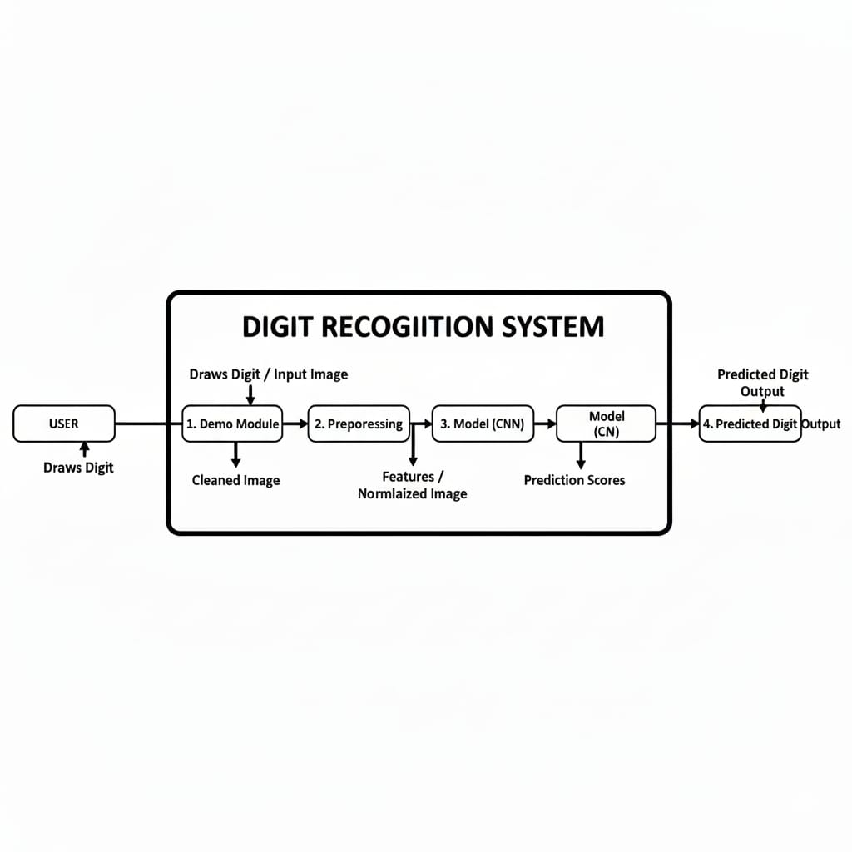
Figure 1: Level 0 DFD

8.2 Level 1 DFD: -
Breaks down preprocessing, model inference, and prediction steps into separate sub-processes. external entities, and data stores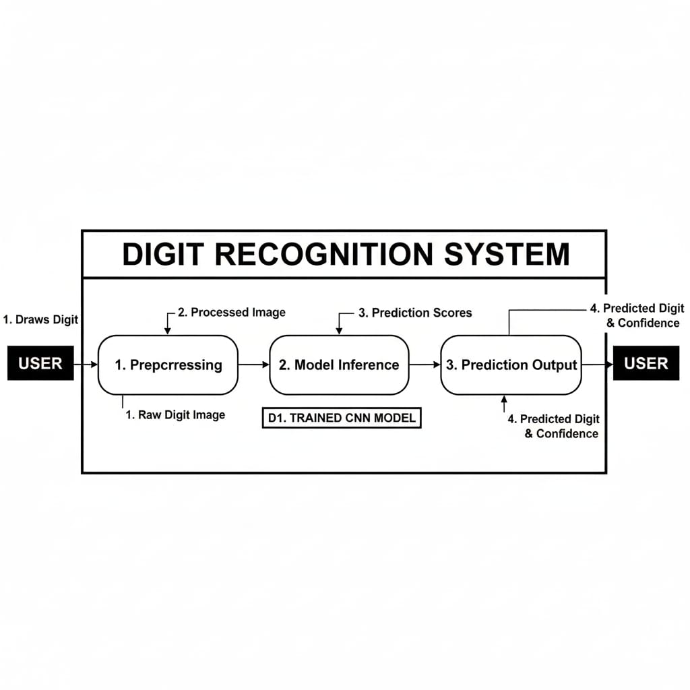

9. ER DIAGRAM
ER (Entity-Relationship) Diagram for a website that manages cohousing societies, along with a
sample application context to help you understand how entities interact within the system.

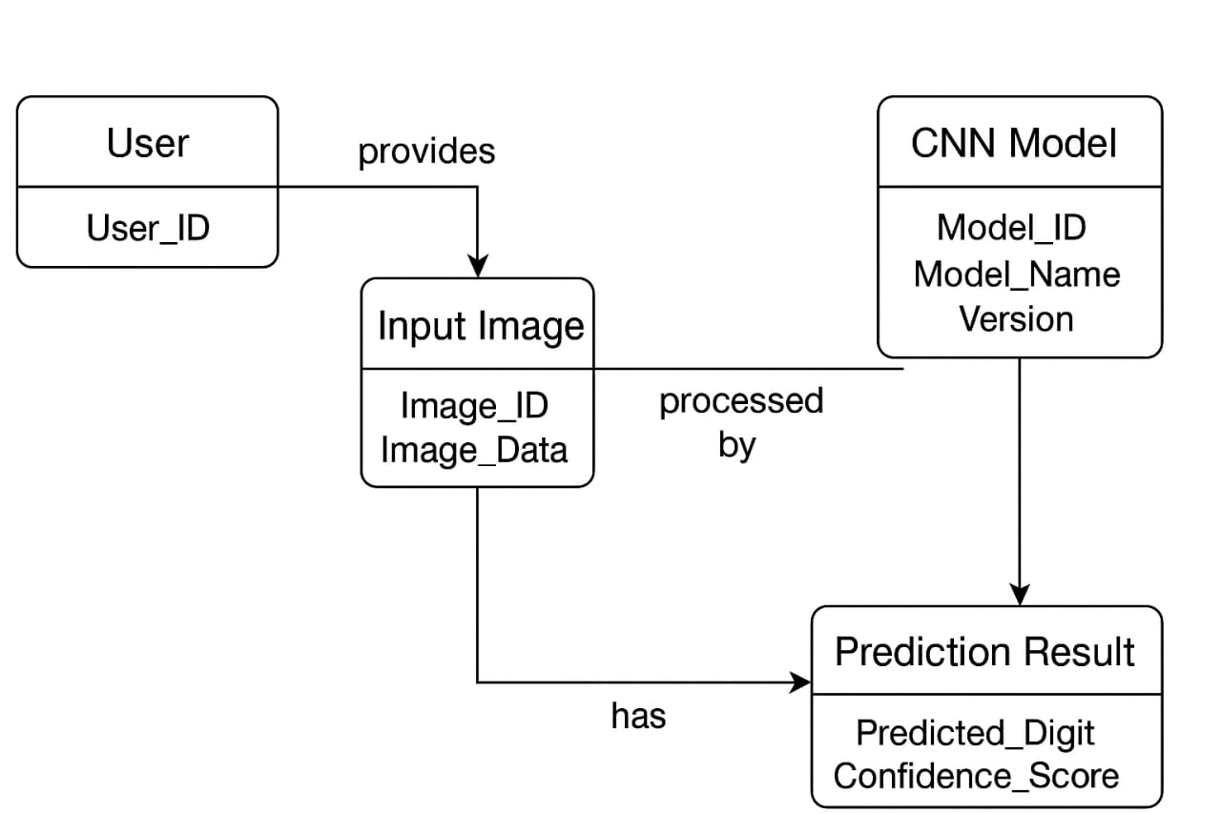
Figure 3: ER Diagram

10. USE CASES

10.1 Use Case: Draw a digit and get prediction.

Actor: User

Preconditions: User opens the demo interface.

Main Flow:

User draws a digit on the canvas.

The system captures the image.

Image is preprocessed and passed to the CNN.

The system predicts the digit and displays the result.

11. CONCLUSION

The Handwritten Digit Recognition System will provide a reliable, accurate, and interactive method for recognizing handwritten digits. By combining deep learning and image preprocessing techniques, the project aims to automate manual tasks, improve efficiency, and offer a real-time demo for practical use. The scalable architecture allows for future extensions, making it a significant contribution to AI-based document and handwriting recognition applications.

REFERENCES
- PyTorch Documentation – https://pytorch.org/docs/stable/index.html
- OpenCV Documentation – https://opencv.org
- MNIST Dataset – http://yann.lecun.com/exdb/mnist/
- Streamlit Documentation – https://docs.streamlit.io/

